New Canopy

**TEST PLAN**

7/03/2023



# Document Description

## Purpose

The purpose of this document is to define the test plan for New Canopy.

It identifies the test approach including scope, test deliverables, test schedule, resource requirements, test environments and any risks associated with the testing.

## Document Version History

This table shows a record of significant changes to the document.

| **Version** | **Date** | **Author** | **Description of Change** |
| --- | --- | --- | --- |
| 0.1 | 07/03/2023 | Kelly Ino | Draft |
| 1.0 | 21/03/2023 | Kelly Ino | For Review |

## Distribution List

|  |  |  |
| --- | --- | --- |
| **Name** | **Role** | **Email** |
| Liam Gallacher | Programme Manager | liam.gallacher@zespri.com |
| Flavia Maier-Cobham | Project Manager | flavia.maier-cobham@zespri.com |
| Berny Roux | Head of QA and Release Management | berny.roux@zespri.com |
| Kyle Beetham | Business Analyst | kyle.beetham@zespri.com |
| Karen Cheng | Business Analyst | karen.cheng@zespri.com |
| Sunny Sun | Senior QA Analyst | sunny.sun@zespri.com |
|  |  |  |

**Table of Contents**

1 Document Description 2

a. Purpose 2

b. Document Version History 2

c. Distribution List 2

2 Document Objectives 4

2.1 Document Audience 4

2.2 Document References 4

3 Overview 5

4 Items for Testing 6

4.1 In Scope Items for Testing 6

4.2 Out of Scope for Testing 7

5 Testing Activities 8

5.1 Test Design Activities and Approach 8

5.2 Test Execution Activities and Approach 10

5.3 Test Automation Activities and Approach 12

5.4 Regression Testing Activities and Approach 15

6 Definition of Ready 15

7 Definition of Done 16

8 Test Environments 17

9 Browsers and Devices 17

10 Roles and Responsibilities 17

11 Defect Management 18

9.1 Defect Severity Definitions 18

9.2 Defect Priority Definitions 18

9.3 Defect Triage 18

12 Testing Risks and Contingencies 19

13 Change Control and Environment Updates 20

14 Entry and Exit Criteria 21

15 Suspension Criteria and Resumption Requirements 22

16 Test Deliverables 22

17 Environmental Needs 22

18 Schedule 23

# Document Objectives

The objectives of this document are to:

* Describe the QA and Testing process(es) and milestones for this solution.
* Identify the types of resources and the estimated quantities / duration for which they will be required to deliver the Quality Assurance and Testing components of the solution.
* Describe the level of reporting to be delivered at each milestone and any pre-requisite benchmarks or project deliverables required to support those reports.
* Describe the Quality Assurance environment requirements

This document is **not intended to**:

* Provide any results of the quality assurance activities



## Document Audience

This document is intended for use by:

* The Business Owner or Sponsor who must confirm that the QA plan will deliver sufficient information for them to make an informed consent regarding the ACCEPTANCE of the solution when delivered.
* The Business Stakeholders for the impacted areas who will be required to provide resources to support Quality Assurance and Testing during the Project.
* Solution Designers / Project Manager who will need to ensure that any required test data / information is designed into the solution / project plan.
* Quality Assurance Analysts who will use this as the foundation document for test planning, execution and reporting.
* Solution Providers who will need to ensure that they have captured any required baseline information and/or any progress information as specified by QA.
* IS Operations who will use this document as a guideline for capacity and provisioning requirements for the creation of Proof of Concept environments, the provision of testing environments etc.
* The Project Manager who will use the document for time and cost estimation purposes and incorporate key milestones into their project plan.
* Other Project Team members as may be required.

## Document References

| Ref No | Document Name | Author | Version | Relevant Links |
| --- | --- | --- | --- | --- |
| 2.2.1 | Project Brief |  |  | [New Canopy - Project Brief.docx](https://zespri.sharepoint.com/:w:/r/teams/PRJ_HORIZONTRANCHE2-EXT/Shared%20Documents/VS%20I%20Grower%20Enablement/01%20Initiation%20%26%20HLD/05%20Requirements/New%20Canopy/New%20Canopy%20-%20Project%20Brief.docx?d=wfcbb783e11424ccb958f05230714b4ae&csf=1&web=1&e=2MdBIB) |
| 2.2.2 | User Stories | Various | N/A | [Issue navigator - JIRA (atlassian.net)](https://zespriqa.atlassian.net/jira/software/c/projects/NC/boards/306) |
| 2.2.3 | Test Strategy – Grower Enablement Programme | Allison Fincher | V03 | [Zespri Programme Horizon - Grower Enablement Tranche 2 - Test Strategy Draft V03 WIP draft.docx](https://zespri.sharepoint.com/:w:/r/teams/PRJ_HORIZONTRANCHE2-EXT/Shared%20Documents/VS%20I%20Grower%20Enablement/01%20Initiation%20%26%20HLD/02%20Deliverables/Test%20strategy/Zespri%20Programme%20Horizon%20-%20Grower%20Enablement%20Tranche%202%20-%20Test%20Strategy%20Draft%20V03%20WIP%20draft.docx?d=w4af27ced0ea4467690c1ec8b59345f9d&csf=1&web=1&e=VA5EUG) |
| 2.2.4 | Digital Quality Assurance Framework |  |  | [Standards & Policies](https://zespri.sharepoint.com/IS/_layouts/15/guestaccess.aspx?docid=0ded0c2f33ce54d84b1a9a5219575632b&authkey=AcksVZ0QKcTmUEGcdPq6nhs) |
| 2.2.5 | Zespri Defect Management Standards |  |  | [Standards & Policies](https://zespri.sharepoint.com/IS/_layouts/15/guestaccess.aspx?guestaccesstoken=C8m2zzJAngrsm%2bnGC4VqOASug3UubWX57vZr8UwVeEE%3d&docid=01b7e72bd858d452ca78df1c4ca0ce175) |

This section contains the list of all materials that support this test plan

# Overview

Zespri currently provides digital services for the Growing community through different platforms amongst which Canopy, Industry portal, Contractor portal, Spray Diary and the Maturity Clearance system are just some examples.

Canopy is one of the main platforms where users can access knowledge articles, latest news, events, industry reports, calculators and other information. Currently Canopy is built on SharePoint and the experience that Canopy provides is no longer fit for purpose due to reasons such as difficulty to find the right content, causing stakeholder dissatisfaction, leading to frustration and negative sentiment. In the Zespri Grower survey in 2022, it was suggested that the digital experience on Canopy be improved so that it will be easier to navigate and search information.

The New Canopy project under the Horizon Programme aims to help reduce user frustration, increase Grower engagement and ultimately increase Grower sentiment and satisfaction through a new digital experience. The project is a large undertaking and will be the most visible aspect of the Horizon programme to the industry and Growing community.

The New Canopy will include a new platform to host and deliver the content and features. This new platform will use Adobe Experience Manager to host and deliver the New Canopy experience. The build scope will also include the decommissioning and archiving of the current Canopy. The New Canopy will have integration functionalities such as integration to the Zespri CRM system and to the Zespri identity and access management system. Other integration requirements will be determined by the solution design activity.

A significant component of the Canopy is the content hosted and presented to the users of the Canopy. Some content, particularly content which supports the “top jobs”, will be fully transformed. All content will be reviewed, reformatted, and updated to support advanced searching capabilities.

# Items for Testing

* 1. In Scope Items for Testing

The following are the systems that will be impacted by this project.

|  |  |
| --- | --- |
| **Scope** | **Description** |
| New Canopy | AEM will be the platform to host and deliver the New Canopy content and features. The New Canopy will be the center of the testing activities and the features in Table 4.1.1 will be the high level scope of testing. |
| CRM | CRM will be used for storing the grower information as well as credentials of Canopy users will be stored in CRM |
| Others | * Identity and Access Management system * Dynatrace * Google Analytics * Campaign Monitor |

* + 1. The following are the features that will be tested for this project. The detailed items for testing will be defined in the user stories that are in JIRA for the New Canopy.

|  |  |
| --- | --- |
| **Scope** | **Areas** |
| User Management | * Registration * Preferences * Access Zespri Systems |
| Functions and Features | * Search * Navigation * Alerts and Notifications * Online Forms * Document Management * Calendar * Archived Content |
| Content | * Web Content * Publications * Resources * Industry Reports * How to Information * Frequently Asked Questions |
| Content Management | * Creation of New Content * Updates to Existing Content * Publishing of New and Edited Content |
| Link to Other Resources | * Links to Microsites * Link to External Sites * Web Applications * Grower Reports |
| Support | * Administration * Support * Analytics |
| Tools / Calculators | * Access and Navigation to Applications, tools and calculators |

Source: [New Canopy Context Diagram, Online Whiteboard for Visual Collaboration (miro.com)](https://miro.com/app/board/uXjVPs7wfoM=/)

* 1. Out of Scope for Testing

The following are the features that are out of the testing scope. *– This will be revisited once out of scope items are finalized*

* Microsites
* ZGS Canopy
* The re-design and development of .NET applications (e.g., MCS, Spray Diary)
* Redevelopment of Videos or Podcasts
* Re-designing any user journeys that are not included in the ‘top jobs’ list
* Industry Portal
* Content Testing - *this will be added in the test strategy as part of a quality phase but not a functional testing phase*

# Testing Activities

###### Here are the testing activities on a high level:

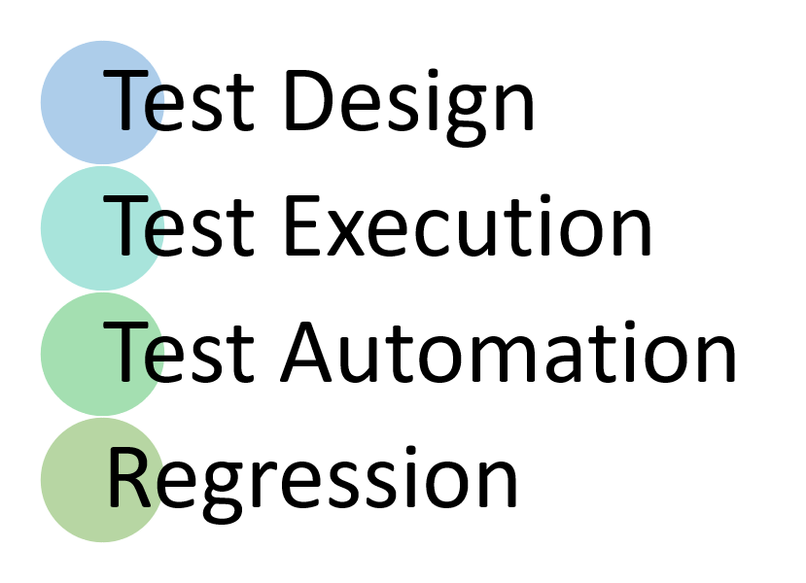

## 5.1 Test Design Activities and Approach

Test design phase involves documenting the test cases and scripts for the features to be tested for the New Canopy project. It includes employing a test management tool to store the test designs and identifying the needed access and test data for each test cases.

###### Epics and User Stories

The test design approach for this project will involve analysis of Epics and User Stories that are stored in JIRA. Each user story will need to have:

* an identified user / role
* an intended objective or goal
* an acceptance criteria that is clear and testable

The contents of the user story will be the basis of the test cases that will be designed and the expected results of each test case will based on the acceptance criteria.

###### Wireframes

Wireframes or mockups will be used as references in creating the test scripts i.e. check the layout, field names, the buttons, and navigation links. Etc.

###### User Stories and Test Cases

Test Cases can be associated to one or more user stories and vice versa. This will be documented using the “**References**” field in Test Rail for each test case. Test Rail is linked or integrated to JIRA so that each user story that is identified in the References field will have a link to that user story for easy navigation.



###### Test Suites and Test Cases

Test Suites and Test Cases will be documented in the test management tool used in Zespri which is Test Rail (<https://zespri.testrail.io/>).

In Test Rail, test cases are designed under a **Test Suite**. A Test Suite is a group or multiple groups of Test cases based on a category. Categories can be Scenarios, Functionality, Priorities, etc. *This can be further defined as the Initiation Phase is completed*.

The chronology of test cases inside a Test Suite should be according to the process they will be executed. Each Test Case will have test steps that explains the procedure that are needed to be done in order to complete the objective of the test case. The objective of the test case will be founded on the user stories that are referenced in the Test case. Each Test case that will be saved in TestRail will have a unique identifier.

Each test step is composed of an instruction which is **the Step Description** and the outcome of each step which is the **Expected Result**.

The test cases will have the following Statuses:

* Test cases will be written with an initial description under the status “Draft”.
* Steps will then be written and if not yet completed can be under the status “In Progress”
* If Test data is yet to be identified, the status of the test case will remain as “In Progress”
* Once steps and test data for the test case are finalized, the status of the test case will be then be “Ready for Review”. At this point, it is expected that References, Execution estimates and other mandatory fields have been filled out.
* The test cases will be reviewed by the Test Lead together with Business Analyst (as needed) to confirm the test coverage.
* Relevant test data should be prepared based on the test case requirement prior to execution.
* In cases where the test case will no longer be designed nor executed, the status will be tagged as Not Applicable.

## 5.2 Test Execution Activities and Approach

###### Test Execution Phases (statements in blue are assumptions as of writing)

UNIT testing of the New Canopy willbe performed by Datacom to evaluate compliance with the specified requirements. This phase will be executed through the sprints, each being focused on the validating code changes and configuration and documenting the results. *This phase will be conducted in the Development environment.*

FUNCTIONAL testing will be performed by the Testing team, to evaluate that the component or the group of components, design or layout satisfies the acceptance criteria of the user story. During functional testing, the execution of tests designed based on the Acceptance Criteria and any variation and negative testing will be executed. Exploratory testing or Ad-hoc tests will be ran during this activity as well. During Functional testing, retesting of defects and associated failed test cases will also be done. *This phase will be conducted in the QA environment.*

SMOKE testing will be performed by users, Business Analysts or any stakeholders and this will be part of Functional testing. This activity is for them to have a view of the functionalities, layout or design delivered near the end of a sprint and to provide timely feedback for any changes or adjustments needed to be considered for the next sprint.

SYSTEM INTEGRATIONtesting will be performed by the Testing team, to evaluate each part of the user journeys that the New Canopy will have. It will also evaluate that applications that are integrated with the New Canopy that are part of the different user journeys. *This phase will be conducted in the QA environment.* During System integration testing, retesting of defects and associated failed test cases will also be done.

USER ACCEPTANCE testing will be performed by Zespri business users, supported by Zespri IS and Datacom as required. The goal of UAT is to evaluate that the system is fit for the user needs and adhere to the requirements agreed with the business stakeholders. *UAT will be conducted in the QA environment. This phase will be after the System Integration is complete. As the project is running in an iterative manner, the items for UAT will be based on what has been delivered after XX sprints and has passed Functional Testing.*

PERFORMANCE testing will be carried out by *TBD*, to evaluate performance and availability of the system against the stated business acceptance criteria in the Project Brief. It will aim to identify any mismatches between performance expectations versus the response of the delivered solution. Performance will be evaluated in parallel with the test phases for System Integration and User Acceptance testing. *A separate Performance testing plan will be written for the details of the testing activities.*

SECURITY/PENETRATION testing will be performed by *TBD*, to evaluate that the system and information are safe, reliable and safety nets are in place to block unauthorized users. *Security will be evaluated in parallel with the test phases for System Integration and User Acceptance testing. A separate Security testing plan will be written for the details of the testing activities.*

DEVICE testing will be performed by *TBD*, to evaluate the New Canopy application is able to support access from mobile devices, regardless of who owns the device.

*The approach will be to smoke test functions that the user journeys that are most likely to be performed on a mobile device. Device evaluation is likely to be in parallel with the test phases for System Integration and User Acceptance*. *Details of supported devices and browsers will be confirmed.*

###### Test Execution Approach

Test execution will commence once all the entry criteria has been met for the testing phase, i.e. System Integration Testing. Test Cases that will be executed will be added to a Test Run. Each test case will be assigned to a specific tester for execution. All Test cases will have an initial status as “**Untested**”. If a test case is deemed as no longer needed for any valid reason agreed with the project team, the test case can be marked **as N/A or Not Applicable.**

###### Test Results

After execution, each executed tests will be tagged as Passed, Failed, Blocked based on the results of testing. If the testing is still yet to be completed for a test case, it can be tagged as **In Progress**.

When a test case passed, the test case is tagged as **Passed** and a screenshot is pasted into the TestRail for evidence of testing.

In cases where a test failed, the test case will be tagged as **Failed**, and a defect will be logged containing the details of the issue and corresponding screenshots. The relevant screenshot of the failed step will be passed to TestRail too.

The JIRA ticket number will be mapped to the failed test in TestRail under the Defects field. This will then be a link to the JIRA ticket. If the succeeding tests cannot be ran due to the defect, these will be tagged as **Blocked** and associated with the defect that caused the failed result.

One or more defects can be associated to the tests. All failed tests should have an associated Defect.

All defects are logged in JIRA and will be discussed with the project team during the defect triage.

###### Retesting associated with Resolved Defects

All defects that are ready for testing will be assigned to the Tester for Retest. The defect will be retested along with the test or group of tests that failed and are related to the defect. Once the defect passed retest and tagged as resolved, the corresponding tests in TestRail will be marked as **Passed** as well. The succeeding tests that have been marked as **Blocked**, if any will be tagged as **Un-tested** to indicate that the execution can proceed.

## 5.3 Test Automation Activities and Approach

***This section will be revisited when a Senior Automation Tester has onboarded.***

* **Test Automation Tool and Framework**

**Tosca,** a Model-based test automation tool that uses model-based testing to help organizations accelerate software testing while maintaining high levels of quality

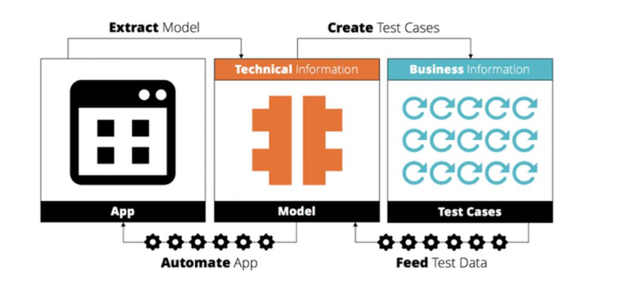

* **Automation Test Types:** 
  + **Unit Automation Testing,** needs to be carried out by Developers to ensure the coding quality is met
  + **API Automation Testing (if applicable),** will be done by automated testers (need discussion with developers to know if it is applicable)
  + **UI/UX** **Automation Testing,** will be done by automated testers

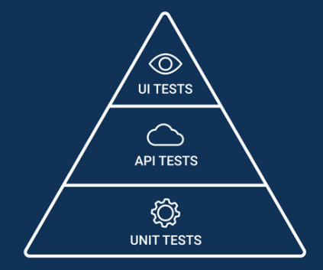

* **Automation** **Testing Entry Criteria**
  + To facilitate automation testing, **developers** need to **give each of UI elements a unique ID or Name or Inner Text** that will help to locate the UI elements. Tosca will normally search for an ID first, then name, then InnerText etc.

Here are some examples (**locate elements via ID and name)**. 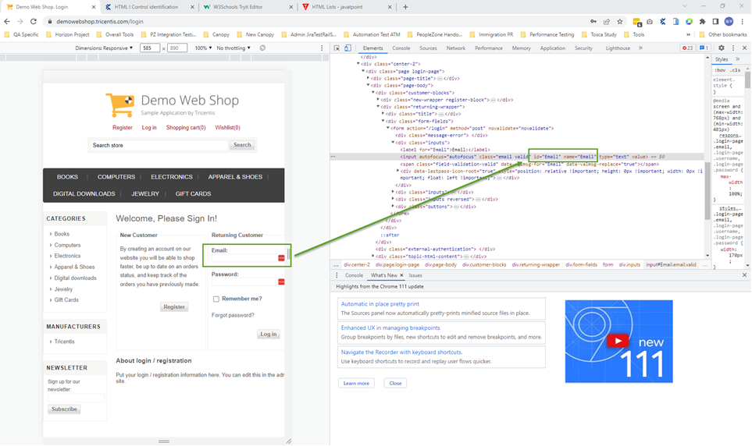In Tosca, when we scan the module, we will find the relevant ID and name as shown below 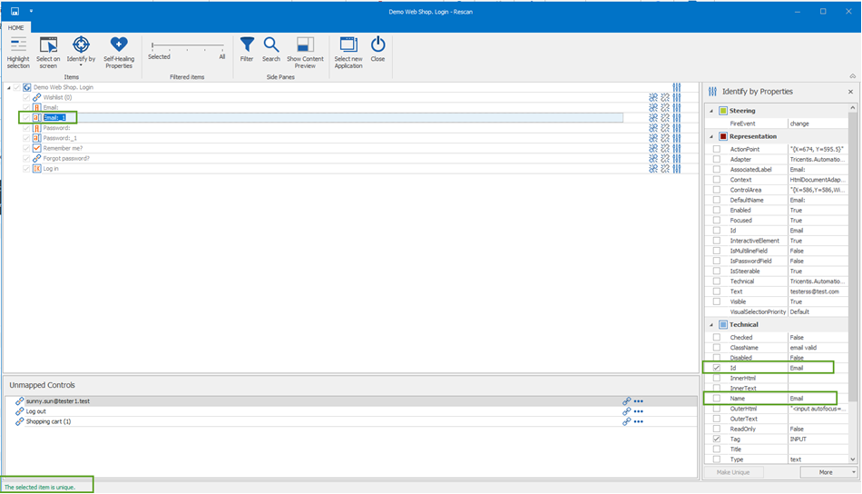

* **Test Automation will have the following activities on a high level**
  + **Initial Assessment for Automation**
  + **Automation Design and Build**
  + **Automation Demo**
  + **Automation Run/ Execution and Sign off**
* **Initial Assessment for Automation**

Initial Assessment is crucial to identify the scope and objectives of the automation effort. In this New Canopy project, the automated testing will mainly focus on UI/UX testing, which can be used to run regression/smoke testing to ensure the work done in previous sprints won’t be broken by the new changes released in the new sprints. The initial assessment can cover below phases

* + **Define the scope (first layer assessment)**: determine the scope of the automation effort by identifying the specific tests, features, or functionalities that will be automated. The good candidates for automated tests can be, but not limited to
* **Repetitive tests:** Tests that need to be run repeatedly, such as regression/smoking tests
* **Stable tests**: Tests that are stable and unlikely to change frequently
* **High-risk tests**: Tests that are critical to the success of the software or that have a high impact on the business or user experience
* **How to achieve**: In the end of each sprint, manual testers can provide a list of tests that meet above standards and pass it to automated testers for further technical assessment
  + **Evaluate the feasibility of automation (second layer assessment):** assess the technical feasibility of automating the identified tests by evaluating the software architecture, identifying the limitations of the existing automation tool, and evaluating the required resources and skill sets.
    - **How to achieve**: Automated testers need to do technical assessment based on the identified tests provide by manual testers and and provide the final list of automatable tests

In TestRail, the two layers of automation assessment can be done via **‘Automate’** field to set relevant values (Assess for Automation, Can be Automated, Cannot/Will not be Automated, etc)

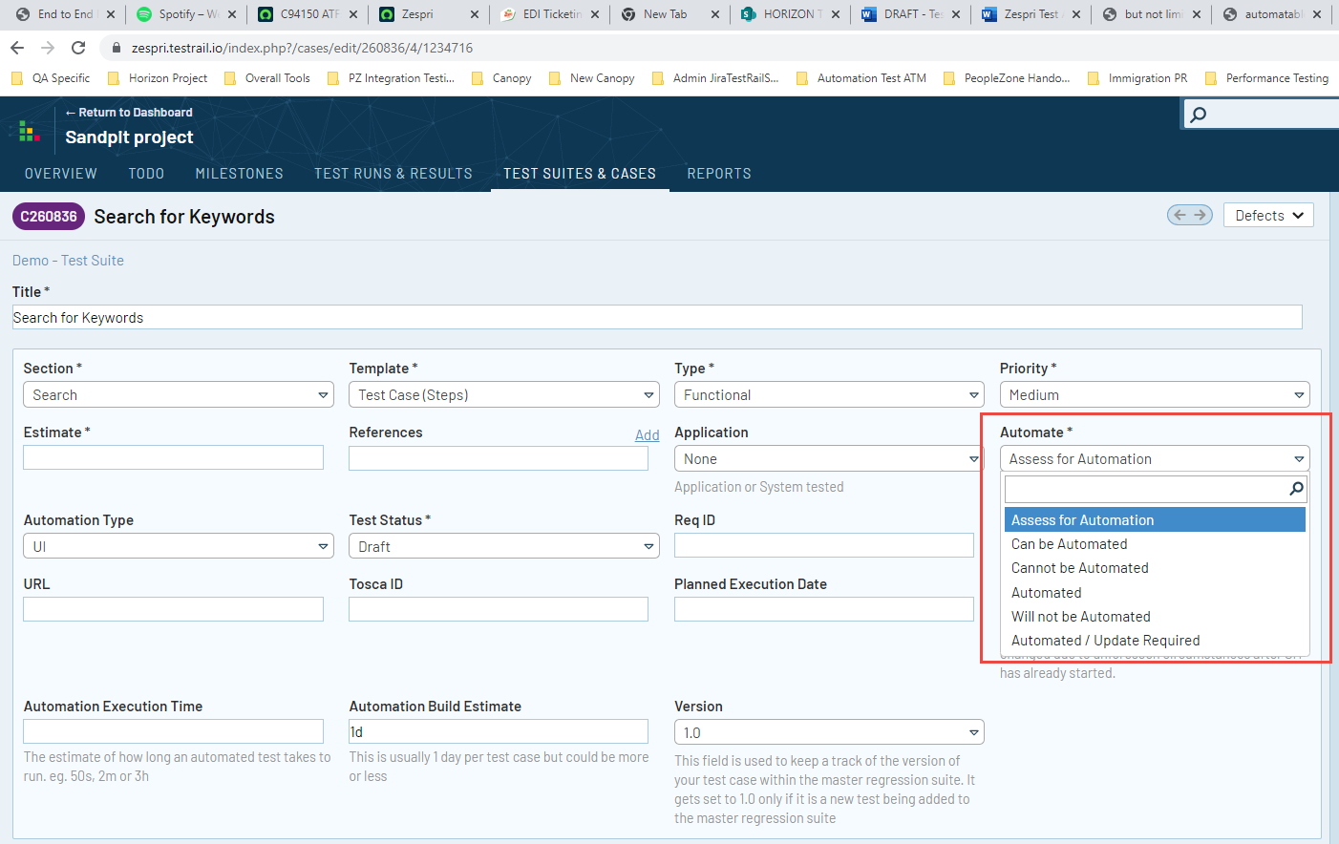

* **Automation Design and Build**

Once the automatable tests list is confirmed, the automation design and build can be started in Tosca by **(**more detailed guidelinesrefer to [Zespri Test Automation Framework_Tosca)](https://zespri.sharepoint.com/:w:/r/sites/DigitalQA/_layouts/15/Doc.aspx?sourcedoc=%7B74C06825-26B2-4979-A180-B6EA1D5D71B5%7D&file=Zespri%20Test%20Automation%20Framework.docx&action=default&mobileredirect=true)

* + Set up folder structures in local master_01 Systems
  + Scan the web application modules
  + Prepare and Create Test Data that can be used in the test steps
  + Create and build tests cases
  + Run the automated tests and validate the test results
  + Peer review to ensure that the tests meet the standards of quality, accuracy, and validity
  + Once Automated Test is created, we must provide and link this test case with the one in TestRail by copying and pasting the Tosca ID in TestRail and update automation relevant fields as shown below



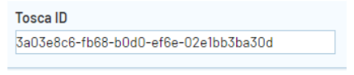

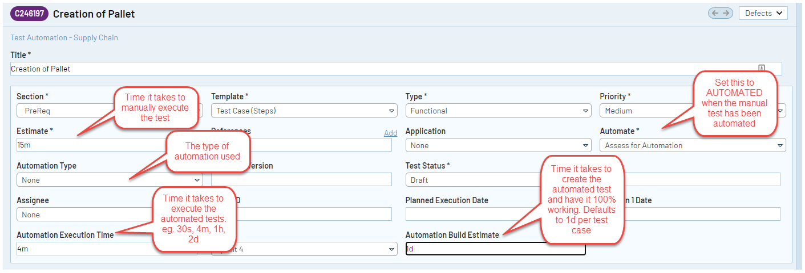

* **Automation Demo**

Once automated tests are ready in the end of each automated testing sprint (always several sprints behind the real sprints). Automated testers can do a demo session to project team to show how it works and what has been covered in the automated testing to build up the confidence and trust in automated testing.

* **Automation Run/ Execution and Sign off**

The actual Execution of Test case is done in the Execution section in Tosca. We are combining the test cases instances into Execution Lists. These execution lists are structured by using Execution Folders or Execution Entry Folders. Each test case is displayed as the execution entry in an execution list. The execution results generated in the Execution list are stored Permanently.

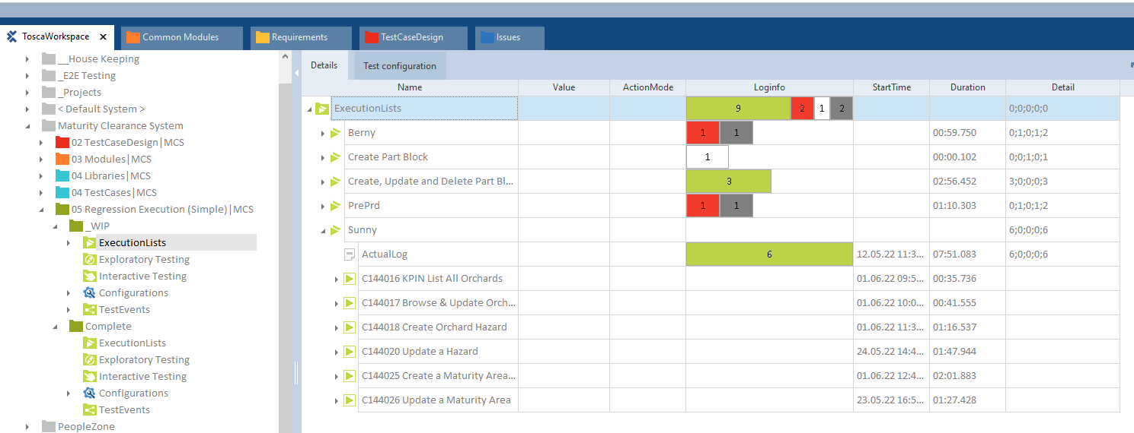

**Execution Frequency:** Automated tests can be executed as part of regression testing in the end of each sprint to verify whether the new release in this sprint has broken the works done in the previous sprints (For tests that cannot be automated, manual testing will be involved to complete the full regression testing).

**Failed Automated Tests:** Automated testers should do the initial troubleshooting (run it manually) to check if the failure is caused by real defects (function error) or Tosca error (time out, etc).

* + If the failure is caused by function error --> Log the defect in Jira and put it into the backlog to be worked on in the next sprint
  + If the failure is due to Tosca error --> optimize the test script to avoid it happening again
  + If the failure is caused by the changes of UI elements (dynamic change) --> may include it into Sprint review meeting to remind developers to try to use unique ID or static context for each of UI elements

**Automation Sign off:** Automated tests need to be sun successfully on DEX Machine as the final sign off

## 5.4 Regression Testing Activities and Approach

Regression testing phase will aim to validate that the functionalities are not impacted by the recent changes to the system.

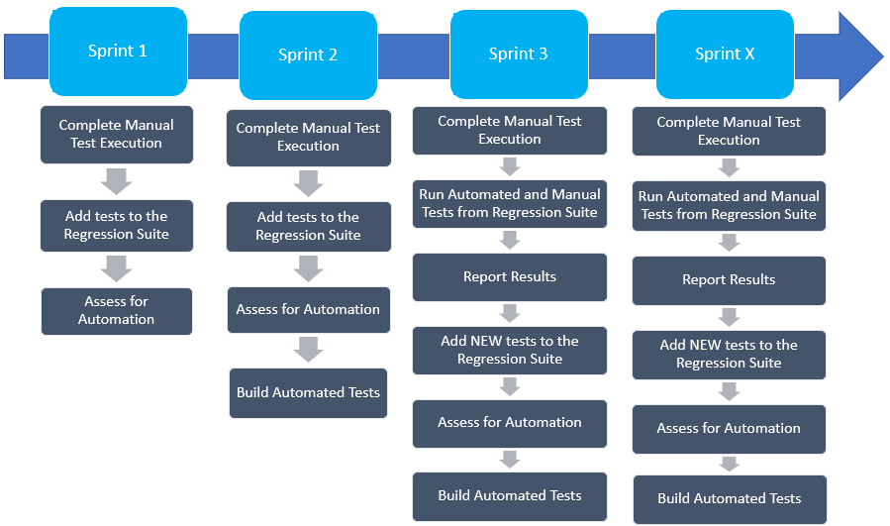

* The regression testing suite will be comprised of tests related to the functionalities from the first few sprints.
* The tests in the regression suite will be assessed and built for automation
* The automation build will generally be a sprint behind the development depending on the number of automatable tests.
* Once built and working successfully, the automated tests will be ran in the following sprint as part of regression testing.
* The tests that are not automatable, if any, will be ran manually as part of regression testing alongside automated tests.
* New tests from the current sprint will be added to the regression suite as new functionalities are tested and passed. The new tests will undergo the similar process of assessment for automation and then built when automatable. This will be done for every sprint.
* Once sprints are completed, the regression suite consisting of Automated and Manual scripts will be ran during UAT for the purpose of regression.

# 6 Definition of Ready

A User Story that is tagged as Ready means that the criteria has been met for the story to move from BACKLOG to a SPRINT. This is the outcome of the grooming sessions of user stories. The Team must have reviewed, given their input and clarified questions during the grooming sessions. The user stories can be updated in order to move the story from Backlog and tag it as Ready.

Examples of Definition of Ready are below

|  |
| --- |
| Story is passed INVEST and NF review.  INVEST = Independent, Negotiable, Valuable, Estimable, Small, Testable.  NF = Non -Functional requirements are included as either acceptance criteria or as stories |
| User is identified in Story |
| Story provides customer or end-user benefit |
| Design, development and testing of the user story will be completed in 1 sprint |

# 7 Definition of Done

The Definition of Done is the agreement between the Agile team members and significant stakeholders that the product has been satisfactorily verified and validated. This is different from the Acceptance Criteria of each User Story as the Definition of Done looks into the completeness of the whole iteration or sprint. The Definition of Done is a clear and concise list of requirements that an iteration / sprint must adhere to. An iteration / sprint is not done until this list is satisfied.

Examples of Definition of Done are below

|  |
| --- |
| 100% Unit tests have been run and pass |
| Peer reviews completed |
| Coding standards are met |
| Requirement Driven Design tests have passed |
| Developer, BA agree that the User Story is completed and ready for development |
| Developers have achieved Branch Coverage |
| Test Coverage is required is achieved |
| Automated Unit Tests have been run |
| Snyk has been run over the code to look for vulnerabilities |
| No Open Defects |

# 8 Test Environments

The details of the test environment for the New Canopy project will be added here once available.

*Currently here are the details of what we know and these will be revisited once Technical design and Architecture is finalized :*

* *New Canopy will h*ave a Dev, Test and Prod instance and these will be integrated with the CRM and AEM platforms for the same tiers.
* CRM has 3 Tiers, (Dev, Test, Prod)
* AEM has 3 Tiers (Dev, Stage, Prod)
* Active Directory which is the current identity stack has only one tier.
* *It needs to be confirmed how the setup of test access will be across the different applications if AD has only one instance. We also need to know how to classify internal and external users, Public, Registered, Full and Vault access. Also how do we set up test and prod access.*

# 9 Test Data

*Discuss here the plan for the data that will be used in the testing phases ie user set up when viewing content, how will test users be setup? Who can create content? Approval? Search levels?*

* Test IDs for access level checks
  + Can dummy test ids be created to differentiate users
    - NZ and ZGS
    - External and Internal users
    - Different Levels of Internal Access (Canopy content related)
    - Users external to Zespri network
  + Are test users maintained in CRM for all types? Are there any users Registered via Canopy
  + How do we set up approval rights for New Canopy
  + How do we setup the publish or edit rights?
  + Is a certain access needed for Archiving?

# 10Browsers and Devices

*As per the technical workshop. Datacom/Vickie will provide recommendations to Flavia and team for the browsers and devices. Details to Follow.*

# 11 Roles and Responsibilities

*The following resource profiles are assumed for Testing. Resource profile will be revisited as the scope for testing is finalized i.e. Number of sprints and number of User Stories for a specific duration. Capacity requirements will be defined in the resource plan.*

|  |  |  |
| --- | --- | --- |
| **Testing Role** | **Headcount** | **Responsibilities** |
| Test Lead | 1 | * Manage Team Capacity * Review Test Cases / Test Data * Run Defect Triage (if separate from Scrum meetings) * Generate Test Reports * Generate Test Closure Report * Support in UAT Planning / Kick Off * Support UAT Execution |
| Test Analyst/s | TBD | * Analyze User Stories * Work Closely with BA’s and Developers for Clarifications * Create Test Cases * Plan / Request Test data * Run Test Cases * Log/Report Defects * Retest Defects * Build Regression pack * Support UAT Execution |
| Automation Tester | TBD | * Analyze the tests for automation * Build automated tests * Run automated scripts * Report Results * Log defects * Retest Defects * Build Regression pack |

# 12 Defect Management

Zespri uses **JIRA** as their default defect management software. QA will log all project defects to JIRA and will then be assigned to a developer or another person in charge of resolving defects logged during the project. The test lead will own this process and oversee all defect statuses and resolution.

You can access Jira here [Zespri Jira](https://zespriqa.atlassian.net/projects/SF/issues) to view project Change requests, User stories and Defects.

Please refer to the Defect Management procedure located in the QA Standards & Policies:

[Zespri Defect Management Standards](https://zespri.sharepoint.com/:w:/g/IS/Eb1yfhuNhSxFp43xxMoM4XUBrjtWsCJkCJC4NrVo_ttw2g)

## 12.1 Defect Severity Definitions

Defect severity is business-driven, i.e. what would be the impact on the business if the solution was deployed into production and this defect existed?

The Business Owner and business stakeholders are therefore entitled to the final decision on the severity of each defect. The QA team may assign an initial defect severity based on their understanding of the impact, but it can be reviewed by the business, particularly if the defect is not resolved quickly or delivery timeframes are potentially impacted.

In order to ensure that all teams have a consistent approach to defects and issues, the following classification criteria have been used:

|  |  |
| --- | --- |
| **Severity** | **Description** |
| **1.** | Critical business functionality does not work, and no workaround exists. Cannot deliver until resolved. |
| **2.** | Important business functionality does not work, and a workaround exists but has a significant business impact and is not sustainable. Cannot deliver until resolved. |
| **3.** | Required business functionality does not work, but a workaround exists. Can deliver without fix with approval from the business, with an agreed plan for resolution. |
| **4.** | Desired business functionality does not work, but a workaround exists. Can deliver without fix with approval from the business, with an agreed plan for resolution or further investigation. |
| **5.** | Recorded for business visibility only. No action required unless the fix is trivial and does not impact delivery timeframes. |

## 12.2 Defect Priority Definitions

Defect priority is delivery-driven, i.e. which defects need to be fixed first due to their impact on QA risk, productivity and timeframes.

In order to ensure that all teams have a consistent approach to defects and issues, the following classification criteria have been used:

|  |  |
| --- | --- |
| **Priority** | **Description** |
| **High** | All or most QA has stopped as a result of defect, or a critical test case is impacted. |
| **Medium** | Testing of a high-priority test case or a group of test scenarios is impacted, but other testing can continue in the short term. |
| **Low** | Minimal effect on testing. Only one or a few low-priority test scenarios are blocked. |

## 12.3 Defect Triage

Defect triage meeting will be held Daily (30 mins daily). It will be held to review new and existing defects to ensure that high priority and severity defects are being dealt with and resolved as soon as possible.

# 13 Testing Risks and Contingencies

#### The following are project and software risks which was identified as the critical areas/risks that could impose a threat to the QA.

|  |  |  |
| --- | --- | --- |
| **Risk** | **Contingency** | **Responsible** |
| Lack Of Testing Resource | * Make arrangements for an alternate resource | Head of Quality and Release Management |
| Lack of availability of required hardware, software, data or tools | * The test schedule will move out to an appropriate number of days | Solutions Architect / Project Manager |
| Late delivery of the software, hardware or tools | * The test schedule will move out to an appropriate number of days * The number of tests performed will be reduced * Resources will be added to the test team * The scope of the plan may be changed * The number of acceptable defects will be increased | Project Manager |
| Scope Creep | * Addressed through Change control | Project Manager |
| Late delivery of Requirements/Specs | * The test schedule will move out to an appropriate number of days * The number of tests performed will be reduced * Resources will be added to the test team * The scope of the plan may be changed * The number of acceptable defects will be increased | Project Manager |
| Changes to the original requirements or designs | * The test schedule will move out to an appropriate number of days * The number of tests performed will be reduced * Resources will be added to the test team * The scope of the plan may be changed * The number of acceptable defects will be increased | Project Manager |

# 14 Change Control and Environment Updates

Standard Zespri change policy applies.

Deployment of all changes to the Test environment, will be agreed and coordinated with the Test Lead and Systems Analyst.

All code will have successfully completed Unit and System testing, where applicable, including the integration components being delivered by Zespri partners.

Deployment of all changes to Production will be managed through the CAB process.

# 15 Entry and Exit Criteria



The following are the conditions that need to be satisfied before test execution for each phase commences.

|  |  |  |
| --- | --- | --- |
| Test Level | Entry Criteria | Exit Criteria |
| Unit Testing | * User Stories have passed Definition of Ready | * 100% of in-scope User Stories are covered by positive and negative tests * 100% of tests have passed execution * No defects are outstanding on each User Story |
| Functional Testing | * Tests designed and approved * 100% of in-scope User Stories are covered by positive and negative tests * Test data has been selected or generated * Unit Test results have been provided and are passed * Code / Config has been migrated to the Test Environment. * Access has been provided (ie. Test Environment, Test cases, JIRA) | * 100% of tests have been executed and passed testing (*OR all failed or unexecuted tests have been signed off by the Test Manager and Product Owner (or a suitable business* representative)) * 100% of high priority tests have been automated as regression tests * No high severity (1 or 2) defects are outstanding (*OR all outstanding defects have been signed off by the Test Manager and Product Owner (or a suitable business representative))* * Plan or workaround is in place for all outstanding defects and all failed or unexpected test cases |
| System Integration Testing | * Tests designed and approved * 100% of in-scope User Stories are covered by positive and negative tests * Test data has been selected or generated * Test environment ready with build deployed, test data available and system shaken out | * 100% of tests have been executed and passed testing (*OR all failed or unexecuted tests have been signed off by the Test Manager and Product Owner (or a suitable business representative))* * 100% of high priority tests have been automated as regression tests * No high severity (1 or 2) defects are outstanding (*OR outstanding defects have been signed off by the Test Manager and Product Owner (or a suitable business representative))* * Plan or workaround is in place for all outstanding defects and all failed or unexpected test cases |
| User Acceptance Test | * Tests designed and approved * 100% of in-scope User Stories are covered by suitable acceptance tests * Test data has been selected or generated * Production-like test environment ready with fully integrated system deployed, test data available and system shaken out · * An agreed percentage of high priority tests have been automated as regression tests * No defects are outstanding OR all outstanding defects have been signed off by the Test Manager and Product Owner (or a suitable business representative) * User logons have been supplied to users for testing * Users have received system & test tool training | * 100% of tests have been executed and passed testing *OR all failed or unexecuted tests have been signed off by the Test Manager and Product Owner (or a suitable business representative)* * 100% of high priority tests have been automated as regression tests * No defects are outstanding (*OR all outstanding defects have been signed off by the Test Manager and Product Owner (or a suitable business representative))* * Test Level Entry Criteria Exit Criteria · User logons have been supplied to users for testing * Users have received system & test tool training * A plan for handing any area of the system that has not passed testing is in place (e.g. holding back the code from deployment, or blocking users from accessing faulty features) |

# 16 Suspension Criteria and Resumption Requirements

The following are the suspension criteria and resumptions requirements for testing to progress.

|  |  |
| --- | --- |
| **Suspension Criteria** | **Resumption Requirements** |
| Entry/Exit criteria from prior test phases not met | Exit criteria from test phases must be met prior to deploying code into the next test phase, or agreement gained from the relevant Project Manager and Testing lead |
| Severity 1 defect(s) preventing test progress | Severity 1 defect(s) fixed and re-deployed to test environment |
| Test environment is unavailable / unstable | Test environment becomes available / stable |
| QA resource unavailable | QA resource/Alternate resource becomes available |
| Major change of Specifications / Requirements | Specifications update complete – may lead to new test assessment |
| Test data insufficient for QA | Test data to be populated by Systems Analyst/Architect |

# 17 Test Deliverables

The following are the test deliverables for this project.

|  |  |
| --- | --- |
| **Deliverable** | **Document Link** |
| Test Plan document | [HORIZON TRANCHE 2 - 01 Test Planning - All Documents (sharepoint.com)](https://zespri.sharepoint.com/teams/PRJ_HORIZONTRANCHE2-EXT/Shared%20Documents/Forms/AllItems.aspx?OR=Teams%2DHL&CT=1675117043779&clickparams=eyJBcHBOYW1lIjoiVGVhbXMtRGVza3RvcCIsIkFwcFZlcnNpb24iOiIyNy8yMzAxMTEwNTYwMCIsIkhhc0ZlZGVyYXRlZFVzZXIiOmZhbHNlfQ%3D%3D&isAscending=false&id=%2Fteams%2FPRJ%5FHORIZONTRANCHE2%2DEXT%2FShared%20Documents%2FVS%20I%20Grower%20Enablement%2F06%20Testing%2F01%20Test%20Planning&sortField=Modified&viewid=604ebce9%2D305d%2D40b7%2D8175%2Df8aa70fcaece) |
| Test Cases – TestRail | TBD |
| Issues – JIRA | TBD |

# 18 Environmental Needs

The following are the environmental needs for testing and the role responsible for fulfilling the needs.

|  |  |
| --- | --- |
| **Environmental Needs** | **Responsible** |
| Access to the Test environments for New Canopy, CRM, AEM, etc | TBC |
| Access to TestRail and JIRA | TBC |
| Test data, Test Users and Test Groups created | TBC |
| Access given to Test Team in the test environments | TBC |
| Architecture configured as Integration Design - Integration Architecture | TBC |
| Integration of CRM to New Canopy | TBC |
| Integration of AEM to New Canopy | TBC |
| Devices available, configured with browsers identified in most common use | TBC |
|  |  |
|  |  |

# 19 Schedule

Time has been allocated within the project plan for the following testing activities. The specific dates and times for each activity are defined in the project plan time line. The persons required for each process are detailed in the project time line. Coordination of the personnel required for each task, test team, development team, management and business user will be handled by the project manager and QA Test Lead.

|  |  |  |  |  |
| --- | --- | --- | --- | --- |
| Activity | Planned Start Date | Planned End Date | Actual Start Date | Actual End Date |
| Sprint Planning | TBD | TBD |  |  |
| Test Execution via Sprints | TBD | TBD |  |  |
| Plan UAT Kick off | TBD | TBD |  |  |
| SIT Completion and Sign Off | TBD | TBD |  |  |
| Submit Test Closure report | TBD | TBD |  |  |
| UAT Execution | TBD | TBD |  |  |
| UAT Completion and Sign Off | TBD | TBD |  |  |
|  |  |  |  |  |

**19.1 Test Schedule and Test Phase for New Canopy**

***This section will have the testing timeline aligned with the finalized project timeline.***

